Morning Worship

THE LORD’S DAY

**Sunday, November 24, 2024**

**8:30 and 11:00 a.m.**

**Christ the King Sunday**

**Thanksgiving Sunday**

“I will praise you as long as I live,

And in your name I will lift up my hands.

I will be fully satisfied as with the richest of foods;

With singing lips my mouth will praise you.” Psalm 63:4 & 5

**Welcome** Kari Sharp

**Prelude** Marguerite Wardlaw

***“Come Thou Fount of Every Blessing”***

**Prayer**  Wesley Rouse

**\*Psalm and Hymns of Praise**

**Psalm 100**

(From the Geneva Bible 1599)

**Sing ye loud unto the Lord, all the earth.**

**Serve the Lord with gladness:**

**come before Him with joyfulness.**

**Know ye that even the Lord is God:**

**He hath made us, and not we ourselves:**

**We are His people, and the sheep of His pasture.**

**Enter into His gates with praise,**

**and into His courts with rejoicing:**

**Praise Him and bless His Name.**

**For the Lord is good:**

**His mercy is everlasting,**

**and His truth is from generation to generation.**

***“All People that On Earth Do Dwell”***

**All people that on earth do dwell,**

**Sing to the Lord with cheerful voice.**

**Him serve with fear; His praise forth tell.**

**Come ye before Him and rejoice.**

**The Lord, ye know, is God indeed;**

**Without our aid He did us make.**

**We are His flock; He doth us feed.**

**And for His sheep He doth us take.**

**O enter then His gates with praise;**

**Approach with joy His courts unto.**

**Praise, laud, and bless His name always,**

**For it is seemly so to do.**

**For why? The Lord our God is good;**

**His mercy is forever sure.**

**His truth at all times firmly stood,**

**And shall from age to age endure.**

**Praise God, from whom all blessings flow;**

**Praise Him, all creatures here below;**

**Praise Him above, ye heavenly host.**

**Praise Father, Son and Holy Ghost.**

**Amen.**

***“You Are Good”***

**Lord, You are good**

**And Your mercy endureth forever.**

**Lord, You are good**

**And Your mercy endureth forever.**

**People from every nation and tongue,**

**From generation to generation,**

***We worship You.***

***Hallelujah! Hallelujah!***

***We worship You for who You are.***

***We worship You.***

***Hallelujah! Hallelujah!***

***We worship You for who You are***

***and You are good.***

**­**

**Offertory Prayer**   Lisa McCurry

**Anthem**  Worship Choir & Orchestra

***“Behold Our God”***

Alyssa Sutton and Rusty Bouchard, soloists

**Who has held the oceans in His hands?  
Who has numbered every grain of sand?  
Kings and nations tremble at His voice;  
All creation rises to rejoice.**

***Behold our God, seated on His throne;  
Come let us adore Him.  
Behold our King! Nothing can compare;  
Come let us adore Him!***

**Who has given counsel to the Lord?  
Who can question any of His Words?  
Who can teach the One who knows all things?  
Who can fathom all His wondrous deeds?**

**Who has felt the nails upon His hands,  
Bearing all the guilt of sinful man?  
God eternal, humbled to the grave;  
Jesus, Savior, risen now to reign!**

**Children’s Sermon** Rev. Gilbert Harris

**\*Passing the Peace** Rev. Harris ***Chorus* O precious is the flow  
That makes me white as snow  
No other fount I know  
Nothing but the blood of Jesus*Verse 2***

**Pre-K childcare begins at 8:15a.m. and those children may be taken by a parent to their class anytime. K – 4th graders go to Kid’s Church during the “Passing of the Peace.” If you have not signed them up for Kid’s Church, please escort your child to the Great Hall.** Ending**For my pardon this I see  
Nothing but the blood of Jesus  
For my cleansing this my plea  
Nothing but the blood of Jesus**

**\*Hymns of Faith**

***“We Gather Together”***

**We gather together to ask the Lord's blessing;**

**He chastens and hastens His will to make known;**

**The wicked oppressing now cease from distressing,**

**Sing praises to His name: He forgets not His own.**

**Beside us to guide us, our God with us joining,**

**Ordaining, maintain, His kingdom divine;**

**So from the beginning the fight we were winning;**

**Thou, lord, was at our side all glory be Thine!**

**We all do extol Thee, Thou leader triumphant,**

**And pray that Thou still our defender wilt be.**

**Let Thy congregation escape tribulation:**

**Thy name be ever praised! O Lord, make us free!**

***“Goodness of God”***

**I love You, Lord. Oh Your mercy never fails me;  
all my days I've been held in Your hands.  
From the moment that I wake up until I lay my head.  
I will sing of the goodness of God.**

***And all my life You have been faithful.  
And all my life You have been so, so good.  
With every breath that I am able  
Oh, I will sing of the goodness of God.***

**I love Your voice; You have led me through the fire.  
And in darkest nights, You are close like no other.  
I've known You as a father, I've known You as a friend.  
And I have lived in the goodness of God.**

**‘Cause Your goodness is running after, it’s running after me.  
Your goodness is running after it’s running after me.  
With my life laid down, I’m surrendered now.  
I give You everything.  
‘Cause Your goodness is running after,**

**it's running after me.**

**Prayer Requests**

**Morning Prayer** Rev. Harris

**THE LORD’S PRAYER**

**Our Father, Who art in heaven, hallowed be Thy name. Thy** **kingdom come, Thy will be done on earth as it is in heaven. Give us this day our daily bread; and forgive us our trespasses as we forgive those who trespass against us. And lead us not into temptation, but deliver us from evil, for Thine is the kingdom, and the power and the glory forever. Amen.**

**\*Scripture Reading Jonah 2:9**

**Message “Thanksliving”** Rev. Harris

**\*Hymn of Invitation**

***“Give Thanks”***

**Give thanks with a grateful heart,**

**Give thanks to the Holy One,**

**Give thanks because He’s given**

**Jesus Christ His Son.**

**And now let the weak say, “I am strong!”**

**Let the Poor say, “I am rich,**

**Because of what the Lord has done for us!”**

**\*Benediction** Rev. Harris

|  |
| --- |
| **Prayer Requests**  **CHURCH STAFF:**  **Rev. Gilbert Harris**, Senior Pastor  **Melissa Tyler**, Executive Director  **Wesley Rouse**, Minister of Music  **Marguerite Wardlaw**, Organist, Music Ministry  **Sandra Rouse**, Pianist, Music Ministry  **Mindy Richardson**,Children’s Choir Coordinator, Music Ministry  **Sherrie Miller**,Children’s Ministry Program Asst./Admin. Asst. (Pastor)  **Donna Henry**, Children’s Ministry Director  **Anna-Lynn Bauer**,Children’s Ministry Coordinator  **Jamie Talley**,Youth Minister  **Lindsey Kizer**,Junior High Ministry Leader  **Andy Blanchard**, Youth Ministry Assistant  **Roger Murphy**, College Ministry Coordinator  **Donna Foster**,Social Media Specialist/Receptionist  **Jennifer Cowan**, Bookkeeper  **Robby Clemens**, Administrative Assistant, Music  **Christy Wheeler**, Director, Preschool Ministry  **Kenny Francis**, Facilities Manager  **Ciarra Smith**,Custodian |

**Missionaries:** Costa Rica – Paul and Amy Priest; Guatemala/Orphanage, Hogar del Nino; Surge - Bruce & Kathy Alwood; Latvia – Kristine Rozefelde; Paraguay – New Horizons Schools; Zimbabwe – Eben and Nancy Chinzvende; Haiti – Gabe Lindor (Simple Church); Haiti – Daniel and Natalie Abercrombie (Access Health Alliance)

**US Based:** Pennsylvania - Shane Claiborne; Tennessee: Raising a Voice, John 3:16, Isaiah House, Smoky Mountain Fellowship of Christian Athletes

**Ongoing Health Requests:** Kenny Allmon, JV Britton, Vicki Borden, Jerry Fugate, Marge Fugate, Judy Granlund, Gerry Lucas, Kermit Marcus, Wanda Marion, Raina Karras Myers, Virginia Porter, Rick Toombs, Mary Wilcox, John Wilson.

**Current Health Requests:**Allen and Jo Beliles, Levi Briskie, Luke Caldwell, Katie Durham, Kenny Francis, Katie Langham, Linda Kidd, Sierra McConnaugley, Bill Merry, Billy Minser, Jessica Moore, Velma Spradlin, Curtis Trent, Janie Watson.

**Military:** Air Force – Steve Burdick *, Charlene Carpenter, Will Gratz, Jeff Heath*, Chad Humphrey, Josh Humphrey, Jef Hyatt, Blaine Nicholson, Jacob Robbins, Danny Smith, Rob Toth, Robb Wilson*, Brian Wright, Jared Cassady. Army – Neal Buckingham, Christopher Cogburn, Luke Cox*, Tony Ellis, Brad Hutsell, Jason McGeorge, Stewart Milne, Tori Simmons, Eli Tate, Wes Tate. Coast Guard – Sidney Fulmer; Marines – Mikeala Buckingham, Tyler Buckingham, Elijah Dean*, Fletcher Dukes*, Derek Reimann, Daniel Romans*. Navy – Jason Cassisi, Kurt Heidemann, Conner Lewis*, Austin Lyttle, Jonathan O'Bannon, Alex Simmons, Jonah Watson*.

Air National Guard – Grayson Beason*, Tyler Isaacs*, Scott Pritchard, Zach Tate.

(*= Deployed)

|  |  |  |
| --- | --- | --- |
| **Welcome Visitors**   | **Prayers/Praises**   | **A qr code with a logo  Description automatically generatedGive** |

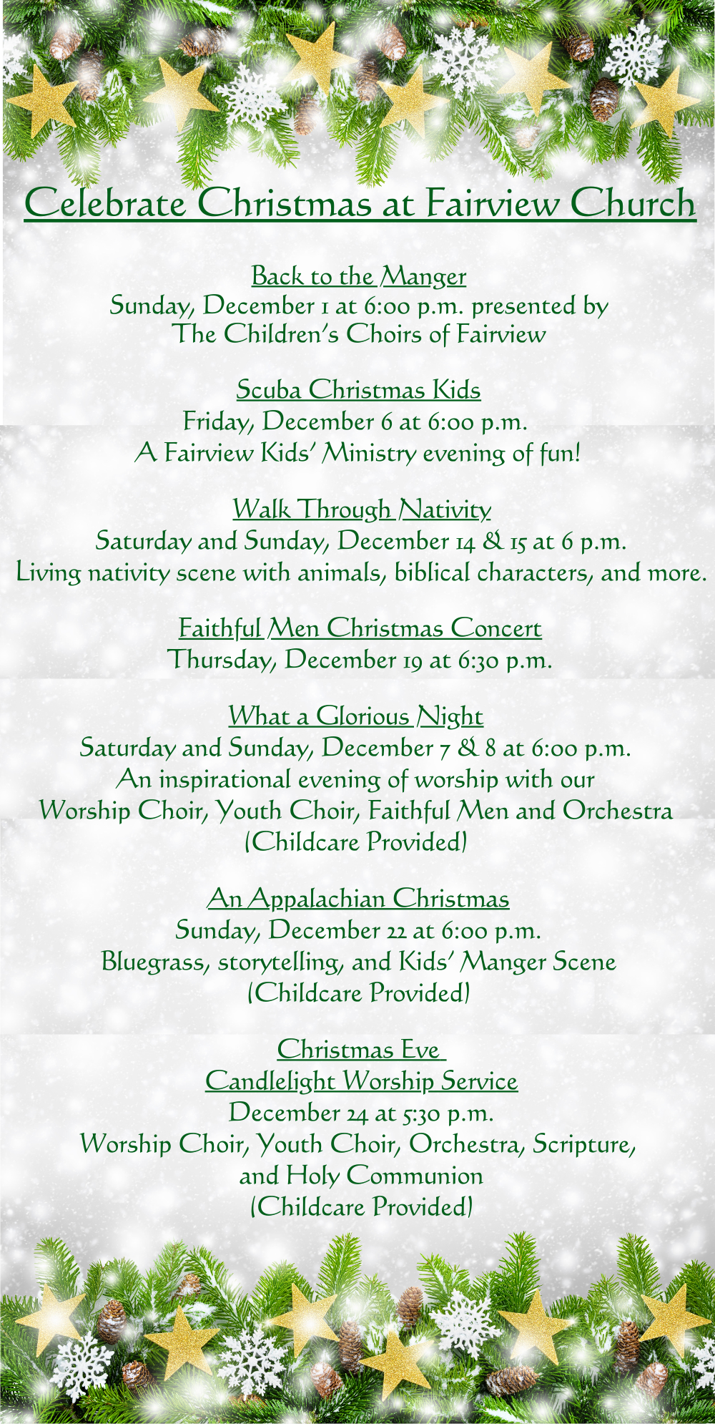



Morning Worship Service

**Sunday, November 24, 2024**

**8:30 and 11:00 a.m.**

**Rev. Gilbert Harris, Pastor**

**Fairview Church**

**2508 Old Niles Ferry Road**

**Maryville, Tennessee 37803**

**865-983-2080**

[**www.Fairview-Church.org**](http://www.Fairview-Church.org)